Individual Assignment – Skincare and consumers needs

Research Methods for Marketers

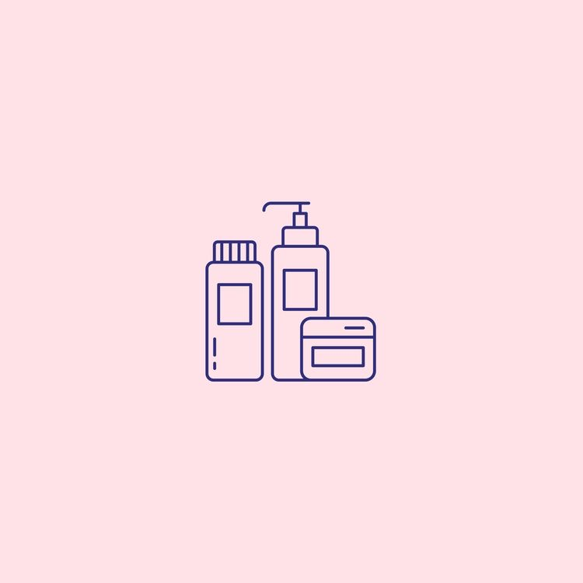

Table Content

- Introduction
- Research Problem
- Research Objectives

Introduction

Pro Skin is a local business based in Leicester, presented under the leadership of Mark Warrington. The company aims to become innovative and to develop a product portfolio. The consumer’s thinking has been shifting toward natural and organic ingredients.

Proposal Plan

Research Problem

The problem which is presented by Pro skin is to assess whether they should introduce a new range of natural/organic skincare products or make it a core of their new positioning.

Research Objectives

Objective 1: To explore the consumer perception toward natural/organic skincare products.

This objective aims to get information about consumer’s perceptions of buying natural/organic skincare products.
Objective 2: To determine whether consumers are willing to buy and try natural/organic products
Identifying consumer’s attitudes towards Pro Skin’s new natural/organic products on the market. It will provide a realistic view of the potential success or failure of the new idea. As a result, it will examine whether the new product will survive in the market.
Objective 3: To examine how much consumers are willing to pay for the natural/ organic skincare products
This objective will help discover how much consumers are willing to spend on natural/organic products.

Data Collection Method

The purpose of this research is to understand consumer's perceptions, opinions, and behaviour. It will help us to make recommendations for Pro Skin's expansion. Therefore, the data gathered for this research will be qualitative research, a type of exploratory research—one of the experimental research cons is that it is very flexible (Ahmed, 2020). Three semi-structured interviews will be conducted through Zoom, it is more convenient for a long-distanced interviewee, and it takes less time than a face-to-face interview. (Saunders, Lewis & Thornhill, 2019, p. 472-475). The interviews' length will take from 30 minutes to 40 minutes and will be recorded to be easier to analyze it afterward (Saunders, Lewis & Thornhill, 2019, p.393).

Sampling Approach

Due to the purpose of the exploratory research the most appropriate sampling method is non-probability purposive sampling. According to Acaps (2011) purposive sampling focus on specific characteristics which will assisted the research, participants who use skincare on their daily basis routine. Thus, the number of participants in this research is small and it does not reflect the whole society, but they can provide meaningful data. Selected participants, will be females aged 22-30 they were selected because their characteristics matched a consumer who use skincare often.

Research Instrument

The research instrument is consisted of four parts. The first part of the research instrument consists of demographics. The other three parts of the research instrument will help to gain data about the consumer’s perception, opinion and monthly financial plan. Semi-structured interview questions will be designed in advance based on the established objectives can be seen in Appendix (add the number later) the questions will be open-ended in order to gather more information.

Appendices

The complete interview guide – Semi – structure interview

Introduction

Good morning/afternoon, thank you for taking the time to be with me today. My name is…. I will be conducting this interview with you today. I want to introduce you to the purpose of this interview. So, the goal of it is to collect data for my research study. Three sections will be covered through this interview relating to your perception of the new product and your opinion toward launching the new products. Also, your budget to spend on natural/organic skincare products.

This interview is going to last approximately 30 minutes to 40 minutes. I would like to inform you that your responses will be recorded. Your identity will be anonymous and will be kept confidential. If you have any queries, please do not hesitate to ask me anytime.

Once more, thank you for being part of my research study.
If you do not have any questions at the moment, we are going to move to the first section of this interview.

Section A: Demographics
First of all, I would like to start with the interview by asking a few introductory questions to find out a little bit more about you …

- What is your name?
- How old are you?
- What is your gender?
- Where are you from?
- What is your current occupation status?
- Do you use skincare products?
- What is your skin type?

Section B: Perception toward the skincare products.
Thank you, the next set of questions will primarily focus on your perception toward the new products.
- What attracts you to buy skincare products? Please explain
- What do you consider as the most important skincare product in your daily routine?
- Do you usually look at the labels on your skincare products?
PROBE: if yes, what are you usually looking at?
- What is the most important ingredient you look for when you are buying skincare products?
- Do you prefer buying natural/organic skincare products? Tell me about it
- Do you see any difference between regular skincare products and natural organic skincare products?
- Do you only consider well-known brands when you buy skincare products?
PROBE: Would you be willing to try different brands?
Section C: Natural/organic product opinion.
Now we will shift towards focusing on your opinion about the new product.
- Have you ever tried natural/organic skincare products?
PROBE: if the participant answers with yes, can you tell me more about your reasons?
If the participant answers no, do you consider buying a natural/organic skincare product?
- Tell me about what you think about natural/organic skincare products?
- Do you prefer that your skincare to be 100% natural/organic?
- Do you think that using natural/organic skincare products will be different that the regular skincare products? Please explain
- What are your thoughts of skincare brands that offer natural/organic skincare?
PROBE: What more can you tell me?
Section D: Budget
We will now discuss your willingness of spending money on the new product.
- Do you use skincare products on the daily basis?
- How often do you buy skincare products?
- Have you ever tried natural/organic skincare?
PROBE: if so, what influenced you to use it?
- How much on average do you spend on skincare every month?
- Would you be willing to pay more for natural/organic ingredient products?
- Do you expect the product to be high quality/low quality comparing to it price?
PROBE: Can you talk to me through that again?

(Thank participant)

References

Ahmed, A. (2020) Exploratory Research Method: Application, Characteristics, Merits and Demerits. Medium. Available at: <https://medium.com/@aquilahmed19/exploratory-research-method-application-characteristics-merits-and-demerits-7da402ebffb4> [Accessed 1 April 2021].
Saunders, M. N. K., Lewis, P. and Thornhill, A. (2019) Research Methods for Business Students. Eight. Pearson Education Limited.

